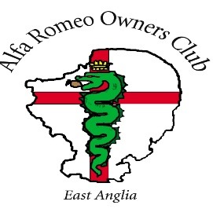
The East Anglian Section Shop
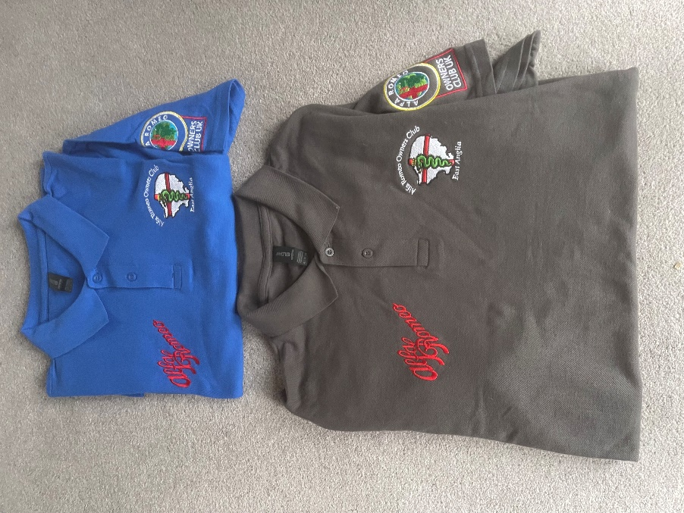
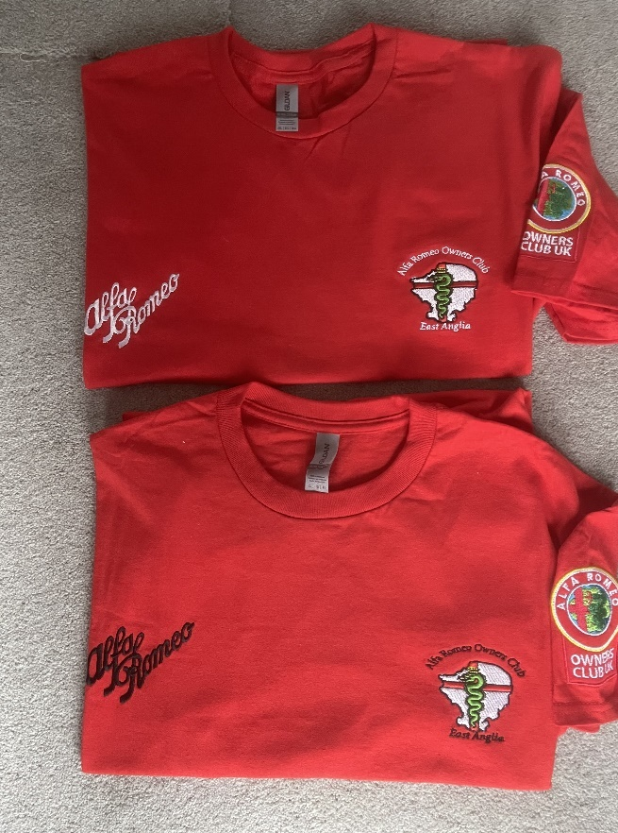
T - shirts and Polo shirts

Available in the following colours
- Red with white Alfa Romeo script.
- Red with black Alfa Romeo script.
- Black with red Alfa Romeo script.
- Blue with red Alfa Romeo script.
- Grey with red Alfa Romeo script.
- White with red Alfa Romeo script.

Fleeces
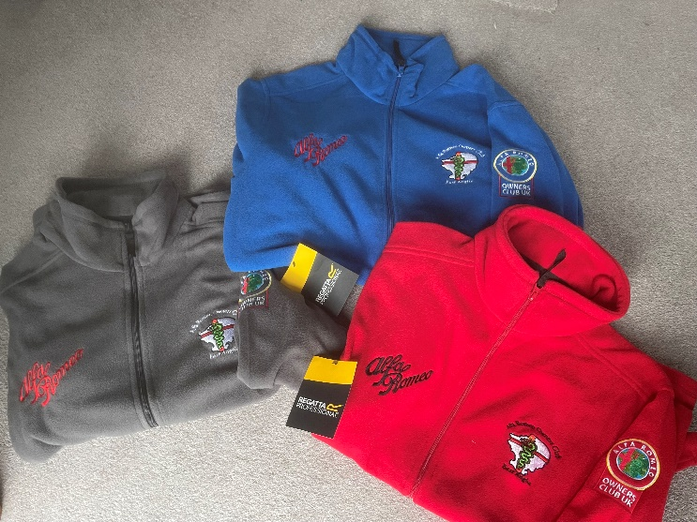
- Grey with red Alfa Romeo script.
- Red with white Alfa Romeo script.
- Black with red Alfa Romeo script.
- Blue with red Alfa Romeo script.

Sizes (Please note that T shirts and Polo shirts vary in sizing)
Male
 | S | M | L | XL | 2XL | 3XL | 4XL | 5XL
Polo | 34/36 | 38/40 | 42/44 | 46 | 48 | 51/53 | 50/52 | 54/56
T shirt | 34/36 | 38/40 | 42/44 | 46/48 | 50/52 | 54/56 | 58/60 | 62/64
Fleece | 37/38 | 39/40 | 41/42 | 43/44 | 46/48 | 49/51 | 52/54

Female
 | S | M | L | XL | 2XL | 3XL | 4XL | 5XL
Polo | 6/8 | 8/10 | 12 | 14 | 16 | 18 | 20 | 22
T-shirt | 8/10 | 10/12 | 12/14 | 14/16 | 18/20 | 22/24
Fleece | 10 | 12 | 14 | 16 | 18 | 20 | 22

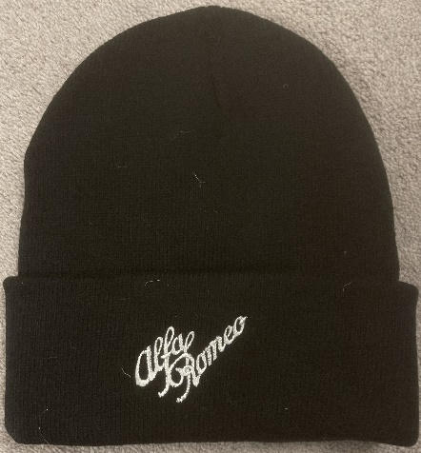
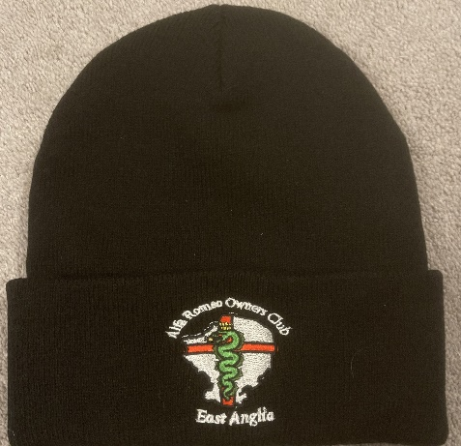
Beanie hats and baseball caps – One size
Front Back
Colours
- Black
- Blue
- Red
Prices (Not including P&P)
- T shirt £22.05
- Polo £27.50
- Fleece £37,50
- Beanie/cap £15.00

Ordering and payment
Payment must be made at the time of the order quoting “EA Shop” as a reference.
BACS transfer to
Bank NatWest
Account 84027126
Sort Code 51-81-10
Name The Alfa Romeo Owners Club Ltd
Ref EA Shop
Please send email with name, contact number, delivery address, garment type, colour size and quantity to.
eashop@aroc-uk.com
Delivery
Items can be collected from section events where possible FOC.
Alternatively, items can be dispatched via Royal Mail as below.
P+P per order
1st Class (no tracking) £4.95
1st Class Recorded delivery £5.95.
Any profits will be put into the section account managed by the treasurer to be used for the section.

Special Offers – All Special offers are on a first come first served basis.
Section car windscreen stickers currently in stock. £1.00 each
Retro AROC car window stickers. £1.00 each
Section windscreen celebrating 100 years of AR 1910 to 2010. 50p each
Blue Beanie Hat – one only – New Old Stock - £10.00
Red fleece (Prototype) as featured above – size 4XL - £20.00.
Baseball Cap (Prototype) as featured above - £10.
Red Beanie (Prototype) as featured above - £10.

