**The East Anglian Section Shop is open!**

For your entertainment and delight , we can offer the items below for ordering for men and women. (Women’s’ garments are tailored to fit ).

Each garment (except hats and beanies) has the section emblem, the Alfa Romeo script. The AROC emblem on the left sleeve. All items are embroidered.

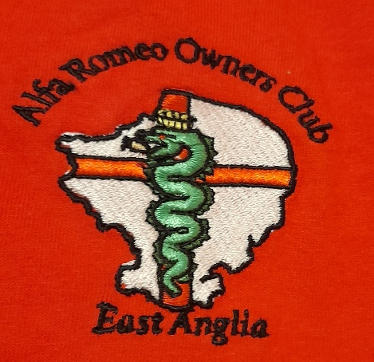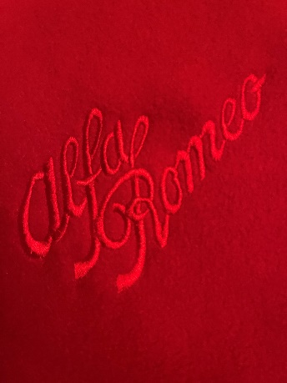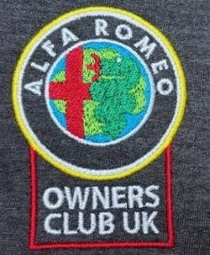

**T shirts and Polo shirts**

Available in the following colours

* Red with white Alfa Romeo script.
* Red with black Alfa Romeo script.
* Black with red Alfa Romeo script.
* Blue with red Alfa Romeo script.
* Grey with red Alfa Romeo script.
* White with red Alfa Romeo script

Sizing ( Please note that T shirts and Polo shirts vary in sizing )

|  |  |  |  |  |  |  |  |  |
| --- | --- | --- | --- | --- | --- | --- | --- | --- |
|  | S | M | L | XL | 2XL | 3XL | 4XL | 5XL |
| M Polo | 34/36 | 38/40 | 42/44 | 46 | 48 | 51/53 | 50/52 | 54/56 |
| M (T shirt) | 34/36 | 38/40 | 42/44 | 46/48 | 50/52 | 54/56 | 58/60 | 62/64 |
| F (Polo) | 6/8 | 8/10 | 12 | 14 | 16 |  |  |  |
| F (T-shirt) | 8/10 | 10/12 | 12/14 | 14/16 | 18/20 |  |  |  |

Prices (not incl P&P)

T shirts £14.95

Polo Shirt £19.95

**Fleeces**

Grey with red Alfa Romeo script.

Red with white Alfa Romeo script.

Black with red Alfa Romeo script.

Blue with red Alfa Romeo script.

|  |  |  |  |  |  |  |  |
| --- | --- | --- | --- | --- | --- | --- | --- |
| M | S | M | L | XL | 2XL | 3XL | 4XL |
|  | 37/38 | 39/40 | 41/42 | 43/44 | 46/48 | 49/51 | 52/54 |
| F | 10 | 12 | 14 | 16 | 18 | 20 |  |

Price (not incl P&P)

£34.95.

Beanie hats and baseball caps – One size (available in two styles)

Club emblem - without writing.

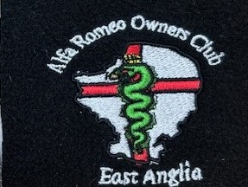Club emblem - with writing.

Colours

* Blue
* Red
* Black

Prices (not incl P&P)

Caps and beanies £14.00

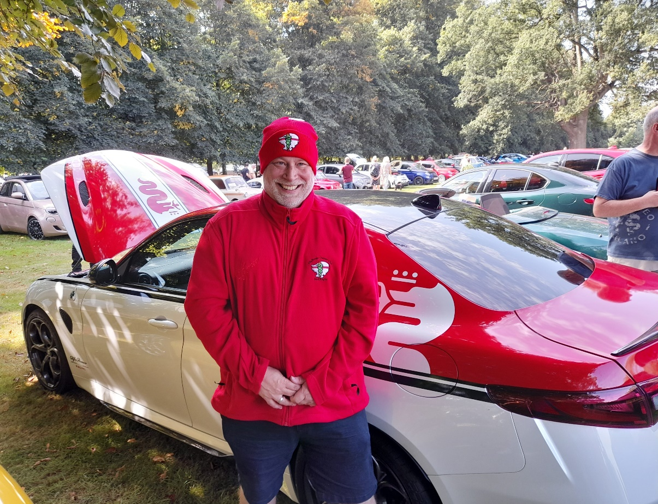

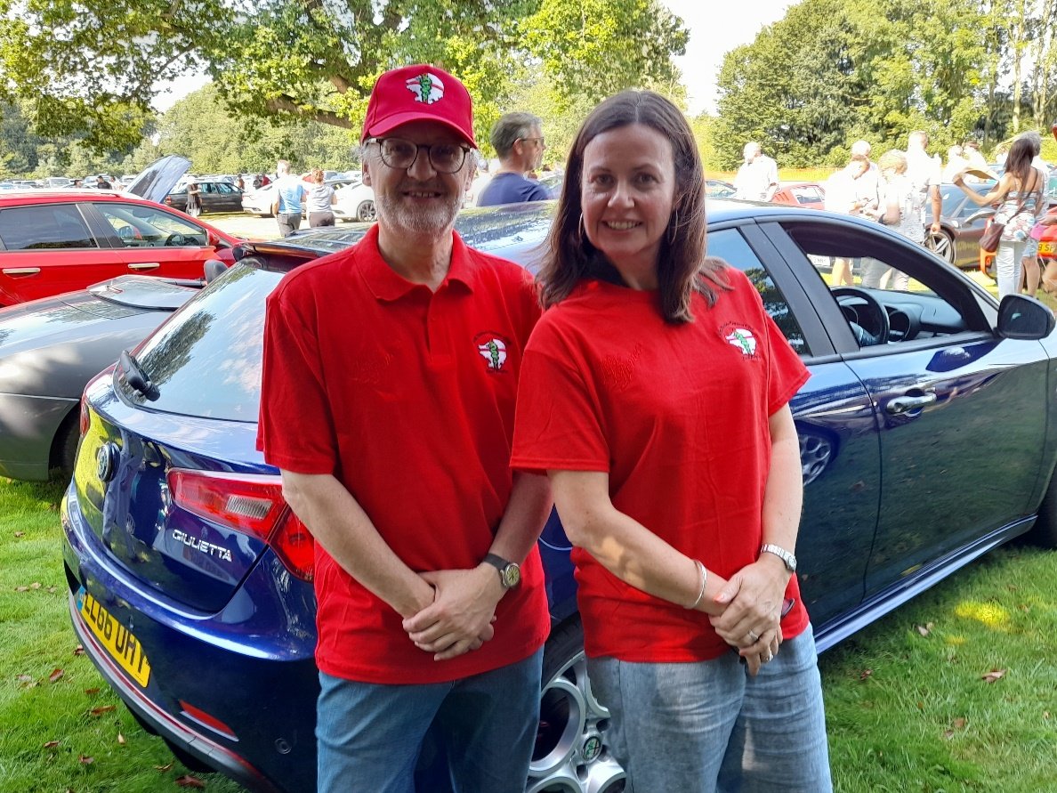

Images above are for Illustration only. These were from the original prototypes and do not show the AROC emblem or Alfa Rome Script Options.

(Models courtesy of Freemans Catalogue.)

**Ordering and payment**

Payment must be made at the time of the order quoting “EA Shop” as a reference.

BACS transfer to

Bank Natwest

Account 84027126

Sort Code 51-81-10

Name The Alfa Romeo Owners Club Ltd

Ref EA Shop

Please send email with name, contact number, delivery address, garment type, colour size and quantity to.

[eashop@aroc-uk.com](mailto:eashop@aroc-uk.com)

**Delivery**

Items can be collected from section events where possible FOC

Alternatively, items can be dispatched via Royal Mail as below.

P+P per order

2nd class (no tracking) - £3.95

1st Class (no tracking) £4.95

1st Class Recorded delivery £5.95

Any profits will be put into the section account managed by the treasurer to be used for the section.

**Special Offers – All Special offers are on a first come first serve basis – offered at the AGM**

There are 20 section car windscreen stickers currently in stock. £1.00 each

There are 17 retro AROC car window stickers. £1.00 each

There are a number of section windscreen celebrating 100 years of AR 1910 to 2010. 50p each

100 years celebratory Polo Shirt in size XL - black. Old Stock – One only – £10.00

Blue Beanie Hat – one only – New Old Stock - £10.00

Red fleece (Prototype) as featured above – size 4XL - £20.00

Baseball Cap (Prototype) as featured above - £10

Red Beanie (Prototype) as featured above - £10

**Shop News**

Other items such as mugs and stickers will be added to shop stock in the near future once the venture gains momentum. So, the more initially sold will increase the range of items available in the future and build a stock.

Ideas from club members as to the merchandise they would like to see possibly offered can be sent to the shop email above.

These will be considered by the committee who will have the final decision on whether they get added to the shop.